

Data sheet (lab 1)

Course: CSE209 Electrical Circuits

Title: Introduction to Circuit Elements and Variables

Submitted By:

D.M. Rafiun -Bin- Masud

ID: 2019-3-60-137

Department of CSE

Submitted to:

Rashedul Amin Tuhin

Senior Lecturer,

Department of Computer Science and Engineering

Pre Lab:

Circuit diagram using PSpice simulator

For 5V,

For 6V,

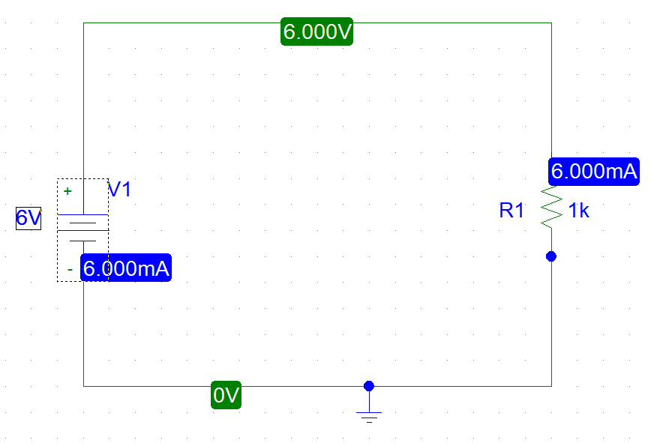

For 7V,

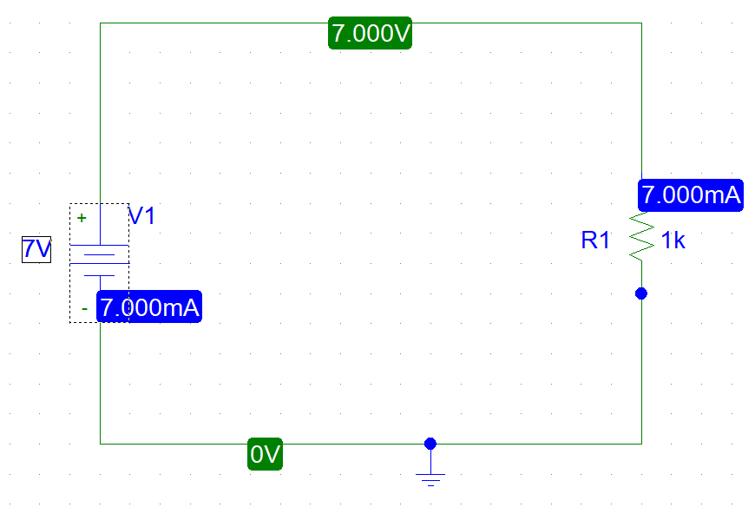

For 8V,

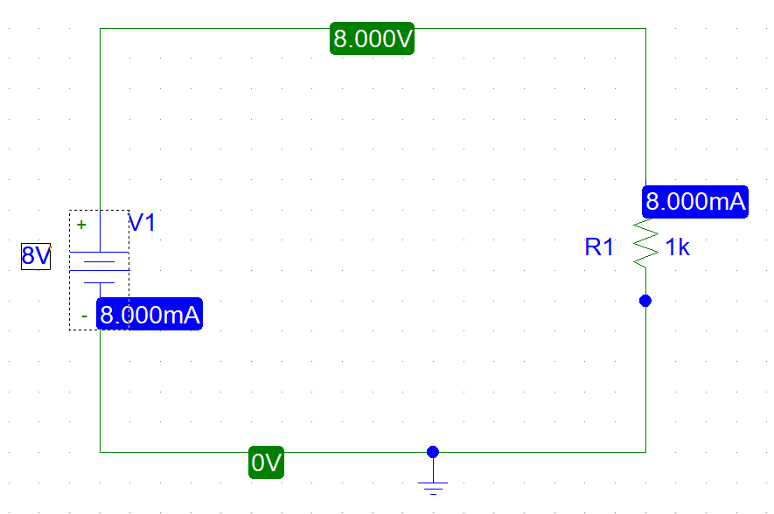

For 9V,

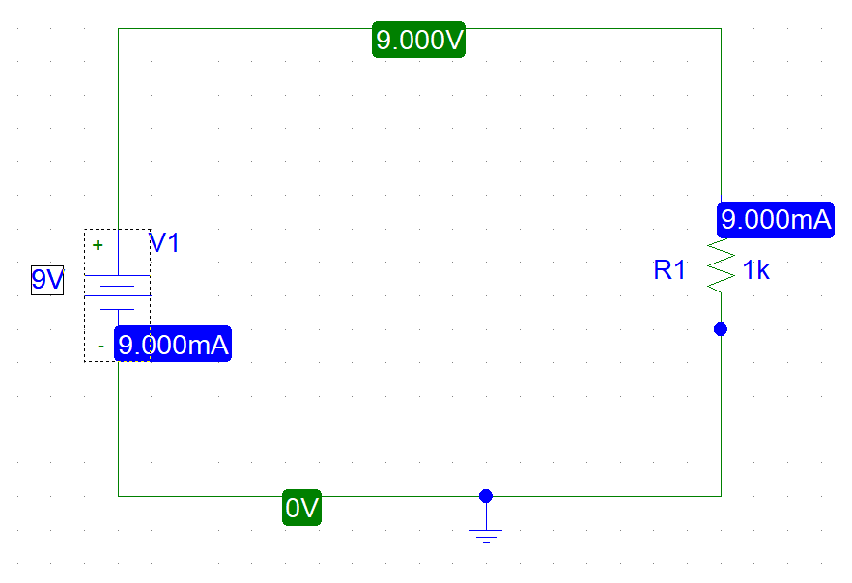

For 10V,

